Director Certification Program
Application

Chapter Name__________________________________ Chapter #__________Region_______________
Name_____________________________________________ Membership #_______________________
Address_____________________________________________ Home Phone______________________
________________________________________Alternate Phone________________________________
Zip_______________ Fax________________________ Email__________________________________

Current Sweet Adelines International Title/Position
□ Director/Co-director Chapter Name________________________________________
□ Associate/Assistant Director Chapter Name________________________________________
□ Candidate Chapter Name________________________________________
Sweet Adelines International Membership Data
Year joined Sweet Adelines International____________ Has your affiliation been continuous?_________
Please list former chapter(s) and region(s):__________________________________________________ _____________________________________________________________________________________
Sweet Adelines International Experience
□ Chorus Director/Co-director □ International Faculty
□ Associate/Assistant Director □ Judge (_____________ Category)
□ Section Leader □ Quartet Member
□ Regional Leader □ Quartet Coach
□ Arranger □ Chorus Coach
□ Other____________________________
Musical Background
Formal education: _____________________________________________________________________
Other musical training:__________________________________________________________________
Barbershop experience outside Sweet Adelines International:____________________________________
Please list membership in other musical organizations (e.g., NAfME, ACDA, NATS):______________________________________________________________________________

Sweet Adelines International Educational Background
How many regional/international competitions have you attended in the past five years as a:___________
□ Competing chorus director □ Competing chorus member □ Spectator
Please list any international directors' seminars/regional training programs you have attended in the past 2 years:_____________________________________________________________________________________________________________________________________________________________________
Please list regional/international educational event(s) you have attended in the last 12 months:_________ _____________________________________________________________________________________
Personal Goals
What do you hope to gain from enrollment in this program?_____________________________________ _______________________________________________________________________________________________________________________________________________________________________________________________________________________________________________________________

Signature _____________________________________________ Date____________________

Please complete and return this application to international headquarters, along with the $100 USD application fee by check, money order payable to Sweet Adelines International, or by credit card (see below). FOR ONLINE PAYMENTS: To pay online, please email education@sweetadelines.com to request an invoice to submit your payment. (This fee is non-refundable and non-transferrable.)

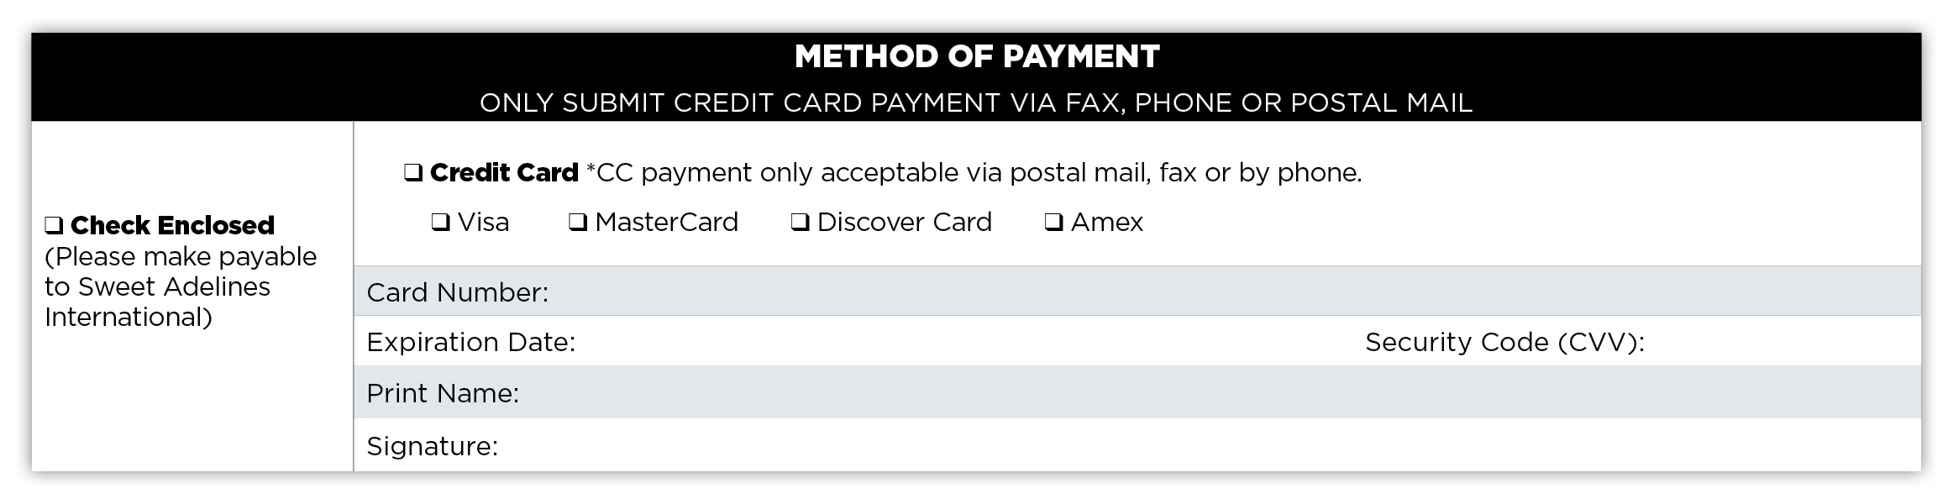

PLEASE NOTE: The application fee to enroll in the Director Certification Program does not include the DCP modules.

Sweet Adelines International ● 9110 S. Toledo Ave. ● Tulsa, Oklahoma 74137
918-622-1444 ● 800-992-7464 ● Fax 918-665-0894 ● education@sweetadelines.com

